Camera Training

**Camera Types**

Nikon D200- 10.2MP

Nikon D300- 12.3MP

**Camera Installation**

* Loosen bracket screws to prepare to put on Spreader bars (Lower set of bars)
* Point head of screws to back of camera box and place on bar and swing into upright position
* Tighten middle screws 1st, then bottom row of screws
  + Allows the camera to be adjusted and also to stay in place once all screws tightened
* Ensure power is off; Plug up power, USB and trigger connections for appropriate lane
* Turn power on power and verify camera is recognized on the camera SW and the Program SW
* Adjust camera to desired position and tighten the top screws

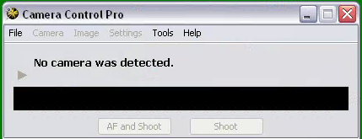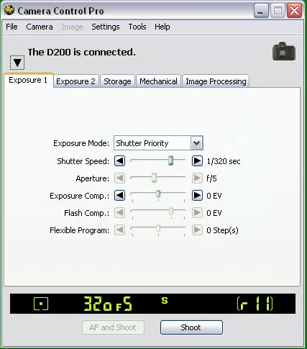

* **Camera not recognized - Camera Recognized**

**Camera Setup w/SW**

* Once camera is recognized by Camera SW, we want to update camera time and settings (Download options, Camera Exposure settings)

**Camera Time**

* Select the “Set Date and Time…” from the Camera menu
* Select “Use Current Date/Time tab and the Camera time will sync with the system time

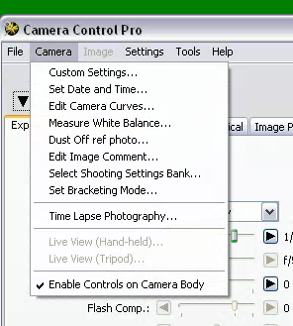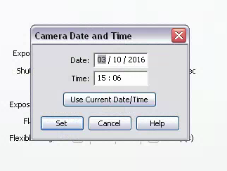**Select this Tab to sync time**

**Camera Menu**

**Download Options**

* Verify the “Download Options” are set to:
  + Ensure that the Path for “Folder for images downloaded from the camera” goes to **C:\optotraffic\unprocessed violation images**
    - **If not select Browse Tab and Follow the path above**
  + Ensure “Next file name to be used” has the File names as seen below:

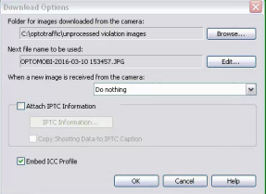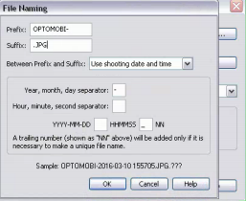

-**Download Option File Naming**

* Ensure the “Do nothing” &” Embed ICC Profile” as seen under Download Options figure

**Exposure Settings**

* Exposure settings are different camera options to help lighten or darken the image being taken
* For our application, there are predetermined exposure settings for the D200/D300 camera (Both have same settings)
* All cameras have Day & night settings that are saved for the camera to load at certain times throughout the day/night
* Exposure 1 & Exposure 2 only updated; after updating any setting always save them by selecting the Settings Tab on camera SW

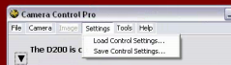

* If either installing a new camera or checking/updating settings, ensure the camera settings are set to the following settings (as seen in photos for day/night)
  + Day
    - **Shutter Speed**- 1/1250 **Exposure Comp**- 0 EV
    - **Sensitivity**- ISO 400; check auto box
    - **White Balance**- Choose color temp. **Color Temp**- 3400-3450K

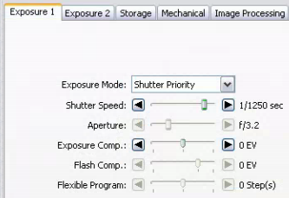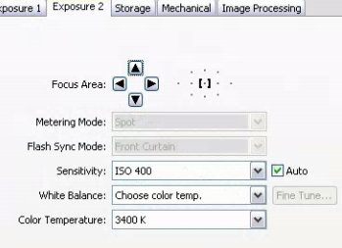

-**Exposure 1 (Day) -Exposure 2 (Day)**

* + Night
    - **Shutter Speed**- 1/320 **Exposure Comp**- 0 EV
    - **Sensitivity**- ISO 400; check auto box
    - **White Balance**- Choose color temp. **Color Temp**- 3400-3450K

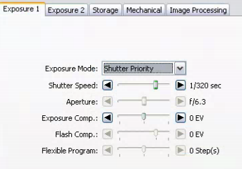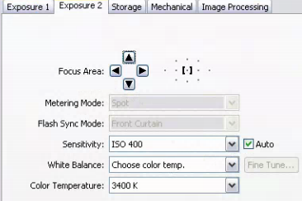

**-Exposure 1(Night) - Exposure 2 (Night)**

* Ensure settings are saved to the respective file; Daytime – 11000.ncc Nighttime– 1250.ncc
* After settings are saved and reloaded, Ensure the camera operation is also verified by taking a series of about 5-10 successive photos to check for operation of camera taking a photo and to verify photos having consistent image quality
  + Account for lag time between the camera SW and the PC taking and loading the photo between snapping the next photo

**Camera Operation**

**Using OTMLRE SW**

* Enforcement SW (OTMLRE) uses camera to snap images of violating cars
* Snaps 2 consecutive photos (50ft & 75ft away from position)
* Settings loaded throughout the day & night by OTMLRE
* Program upload settings for the camera about every 30 min; determined by the time of day
* Any issues with camera operation will cause program to have issue running and enforcing
* Once camera SW setup is completed, next step is to verify camera operation with the Enforcement SW (OTMLRE)
* The SW allows the user to upload the camera settings that are saved by: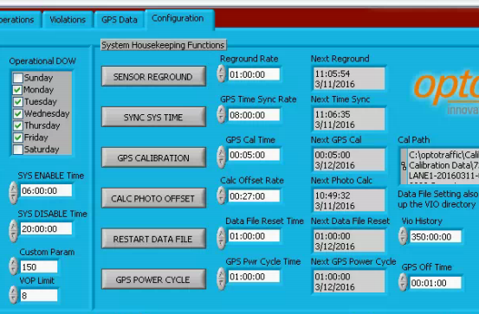
* The camera can be power on/off by:

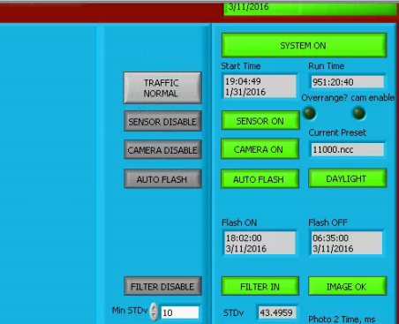

* These operations let us know the camera is working with the SW and if the appropriate settings are being uploaded

**Camera Power/Signal**

***Power***

* Camera powered up by a 12V Power supply located at the far lower back of switch panel tray supplied by the load batteries

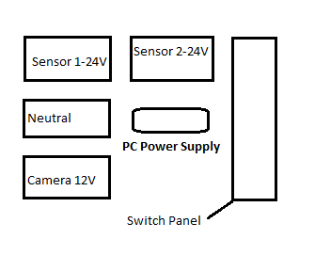

* Wired through switch panel; From switch panel wires run up to the camera power connection giving a set voltage to the camera
* Camera voltage should be set around 13.5-13.6V at the camera junction box
* Power supply should be about .3-.5V off from voltage @ camera
* Verify using either doctors kit or Multimeter

***Camera Signal***

* Camera is recognized by USB cable plugged in the front of the corresponding PC
* Signal of sensor triggering the camera to take a photo is recognized by the RJ45 connector (Cat5 Cable) plugged into interface board of PC tray
* Both needed to be plugged in proper PC and interface port for camera operation to be correct
* RJ45 connection is one-one

**Camera Issues**

Not Recognizing

Disconnecting

Dark/Bright Photos

Camera time/settings incorrect